Exercise 1: Mocking and Stubbing Scenario: You need to test a service that depends on an external API. Use Mockito to mock the external API and stub its methods. Steps: 1. Create a mock object for the external API. 2. Stub the methods to return predefined values. 3. Write a test case that uses the mock object.
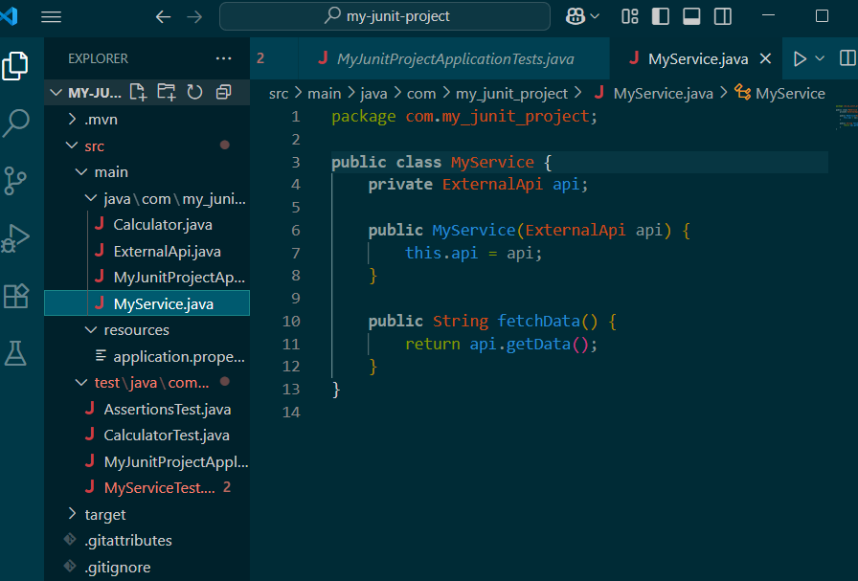
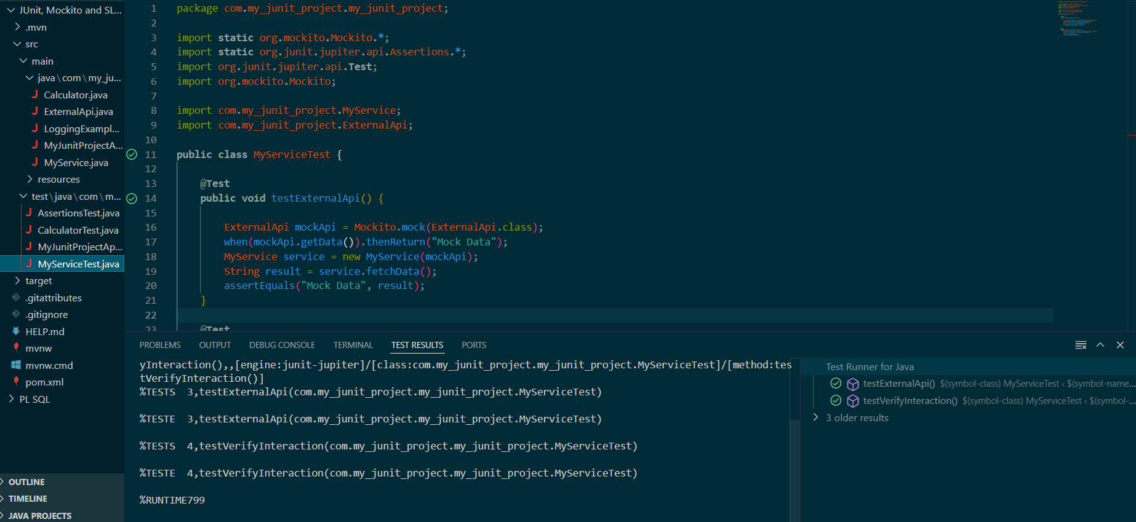

Exercise 2: Verifying Interactions
Scenario:
You need to ensure that a method is called with specific arguments.
Steps:
1. Create a mock object.
2. Call the method with specific arguments.
3. Verify the interaction.
